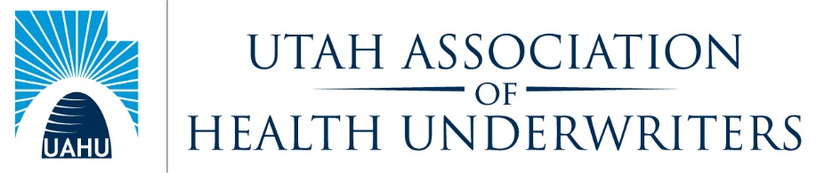
General Board Meeting
Tuesday, March 9, 2021
General Board Attendees: Carl Roestenburg, Jon Clark, Lynn Strate, Josh Schreiber, Ernie Sweat, Lisa Strug, Meredith Levy, Amy DeSpain, Myka Smith, Crystal Cowley Jennine Ashley
Absent: Justin Bendler, Emily Johnson
Welcome: Anti-Trust Statement: Carl Roestenburg
- Thank Jaffe for stepping up with minutes and agenda in the absence of secretary. Still looking for secretary.
- Minutes: Carl made a motion to approve the minutes. Myka seconded the motion. Motion passes.
- Upcoming Events
  - Ethics CE Series - March 10, 2021 Thanks to region 7 for help. 33 so far. Hoping for a few more.
  - CE Event – April 14, 2021Close to getting something together. ICHRA’s Hope to announce tomorrow.
  - Sales Congress – May 19 - 20, 2021
  - Golf outing – June 8, 2021
Sales Congress– Jon Clark
- 2 ½ months away May 19-20
- Still trying to secure more sponsorships. Jon listed potential sponsors that we are looking to see if anyone has contacts.
- Secured U of U Volleyball Coach
- Secured 5 of 8 hours of CE
- Shared the updated sponsor list in the prospectus. Where are the other dental carriers? Where are some of the larger carriers?
- We need to get these potential sponsors to see the demos. If you see glaring misses. Point them out. Help us reach out.
- Where’s MetLife? Doing Demo tomorrow.
- If they are trying to get a foothold, they should be there.
- Jon will send out prospectus to everyone on the board.
- Ryan will work on golf tournament. Hoping to get participants that may not want to come to sales conference. Want to make it profitable and fun.
- Virtual was the right decision. Venue closed through our dates.
- Start working on getting turnout.
Legislative – Ernie Sweat
- DOH80 Registrations
- Meeting tomorrow at 1 with lobbyist. One last communications to members. Hopefully by end of week.
- Bill that was proposed at end of the session that didn’t make it through. Compensation disclosure bill. Will probably hit next year. Pretty quiet.
- Why are people only getting one credit? RaNell looking into it.
- We can do a better a job of being in touch not only during cap con
- Give group a break through the summer and start ramping things up in the fall.
- Summer is a great time to meet with federal legislators.
Myka – No report
Finance – Lynn Strate
- Budget looking good so far. About how we would expect it to look this time of year.
- Myka – can we compare LY and the ethics CE.
- Cap con reimbursement forms.
Health Policy – Amy DeSpain
- Emily Johnson taking Amy’s place after Sales Congress.
- Emily is not here today because she’s on her honeymoon.
- Getting things ready for Sales Congress
Communication – Josh Schreiber
- Facebook and Linked in.
- Linked in post not coming out visually correct.
- No leg updates getting sent to me.
- How do we want to go forward with leg team out of session? Anything we as a chapter need to get out to our members? Will come through Ernie. Need to get all activity to Josh to get it out.
- Let’s take pictures of our zoom evets. Let’s take a pic of tomorrow.

HUPAC – Justin Bendler - absent
Membership/Retention – Jon
- Committee meets every other Friday. Shawn Hewlett- New members, Viraj Gupta- Retention, Lenny Scroggins-Hospitality, Danielle Perry - Former members.
- Meet every 2 weeks on Fridays

Media – vacant
Community Service – Jennine
- Fourth street clinic after DOH received interest in large donation.
Upcoming Activities:
- Ethics CE Series - March 10, 2021
- CE Event – April 14, 2021
- Sales Congress – May 19 - 20, 2021
- Golf outing – June 8, 2021
Positions Open: VP, Secretary as well as Committee chairs including Professional Development. We are looking for people to join us.
Past President- Crystal
NOTES: Next General Board Meeting: April , 2021. 11:00 AM

