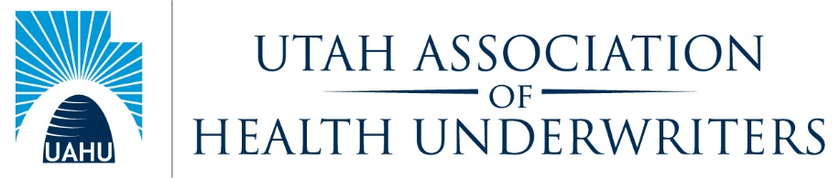
General Board Meeting
Tuesday, August 10, 2021
General Board Attendees: Carl Roestenburg, Jon Clark, Lynn Strate, Mike Deru, Matt Wells, Josh Schreiber, Ernie Sweat, Bart Spencer, Lisa Strug, and Meredith Levy,
Absent: Amy DeSpain, Justin Bendler, Tami Flandro, Lenny Scroggins, Jennine Ashley
Welcome: Anti-Trust Statement: Carl
- Minutes: Jon made a motion to approve the minutes. Carl seconded the motion. Motion passes.
Jon
- Medicare summit. September 14. 3 hour of CE no charge. Virtual. Have enough in sponsors to cover our budget shortfall. All carriers reaching out to their agents. Share the blast with everyone.
- Tami voted in as secretary and Mike Deru voted in as VP by our executive board.
Legislative – Ernie Sweat
- We need to come up with a better way to try to meet our legislators here in Utah.
- HUPAC Senate golf event Carl and Ernie with 2 others on sept 8 Utah house caucus event Aug 25 Dodge Ball $2500
- Day on the Hill
- UHIA Golf tournament?
- For cap con we mostly see aides. Maybe try to set them a little earlier. Maybe Dereck and chase can help set up appointments in Utah and maybe in capcon.
  - What does NJ do? Appoint someone as a cap con chair and take attendee list and match them with their representatives. Then attendee reaches out to make own appointment. Chair meets with attendees to prep attendees.
Sales Congress– Josh
- Organizing committee
- May 17 golf. May 18 sales congress

Past President - Carl:

Finance – Lynn Strate
- Budget 2021-22 was just approved by the executive board

Professional Development – Bart Spencer / Carl
- Welcome to Bart
- Looking at finding an inperson place

Communication – Matt Wells at U of U taking over next month
- Testimonials of UAHU on facebook and linked in
Health Policy – Amy DeSpain. Emily no longer with Select Health.
- Absent
HUPAC – Justin Bendler
- No report
Community Service – Jennine
- Fourth Street Clinic just had a fundraiser
- In the fall they have their match. Will find out details and get it back to us.
- Meet every 2 weeks on Fridays.
Media – vacant
Awards - vacant
Membership/Retention –Lenny Scroggins
- 248 members
- Moving in the right direction.
New Business
- We need to fill the board Awards chair
- Medicare Summit next month
- Sales congress planning meeting
- If you attended NAHU conf, get your receipt in for reimbursement

NOTES: Next General Board Meeting: September 15, 2021. 11:00 AM TBD

